Embed Component

**Live URL** - <https://www.ancestry.com/corporate/family-history-month>

**AEM URL** - <https://author-ancestry-dev2.adobecqms.net/content/ancestry-corp/us/en/family-history-month.html?wcmmode=disabled>

Properties Tab

Type – For adding video we can select any one type as per the requirement. There are 4 types as below -

1. **URL**

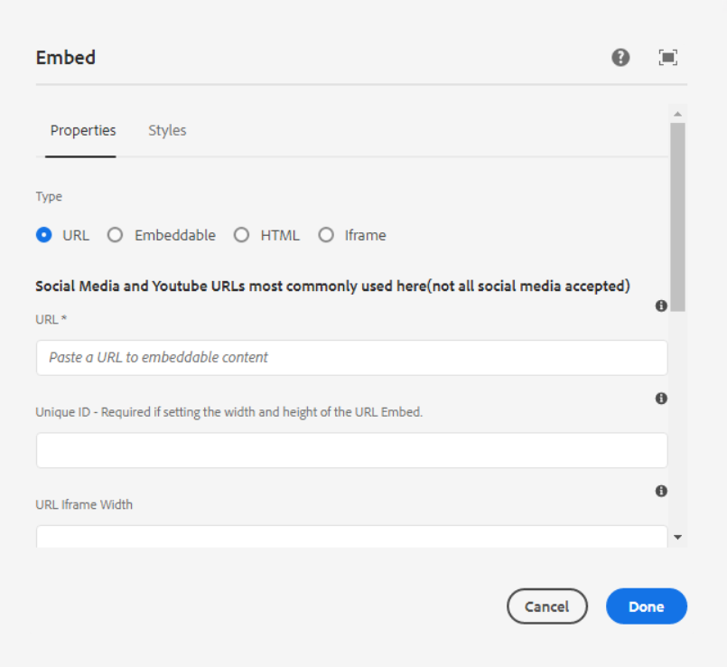

**URL** - The URL of the content to embed. The URL will be checked against supported processors for a match.

**Unique ID** - ID of the parent div of the URL Embed Iframe

**URL iframe Width** - Width of the iframe. Be sure to add the measurement value i.e. % or px

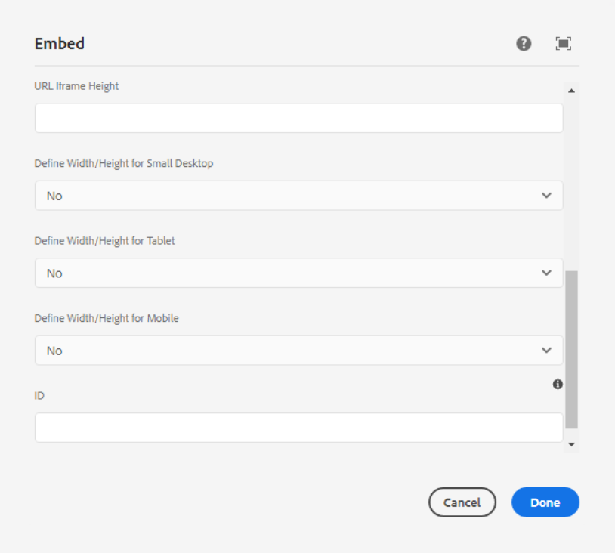

**URL iframe Height** – Height of the iframe. Be sure to add the measurement value i.e. % or px

**Define width/Height for Small Desktop** – In the dropdown, if we select yes then below fields are visible.

Width and height value should be in PX format, % value will not accept

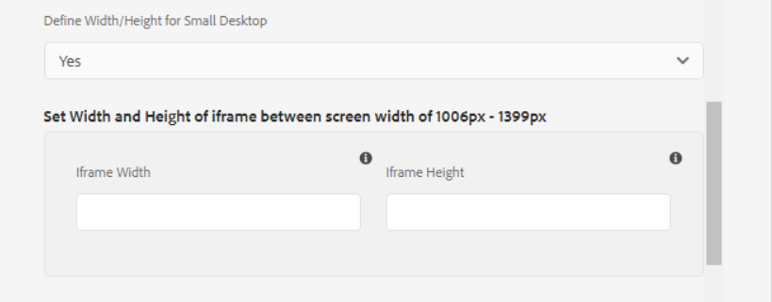

**Define width/Height for Tablet** – In the dropdown, if we select yes then below fields are visible.

Width and height value should be in PX format, % value will not accept

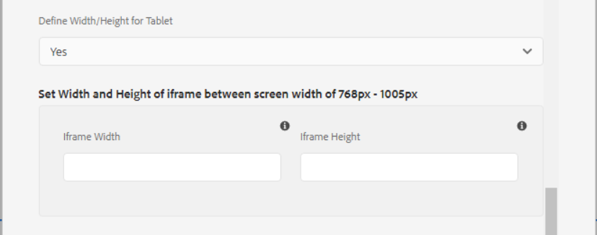

**Define width/Height for Mobile** – In the dropdown, if we select yes then below fields are visible.

Width and height value should be in PX format, % value will not accept

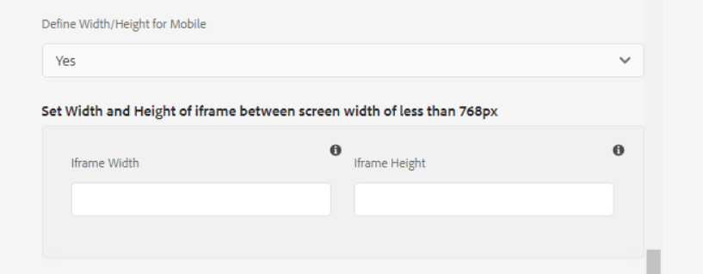

**ID** – HTML ID attribute to apply to the component.

------------------------------------------------------------------------------------------------------------

1. **Embeddable**

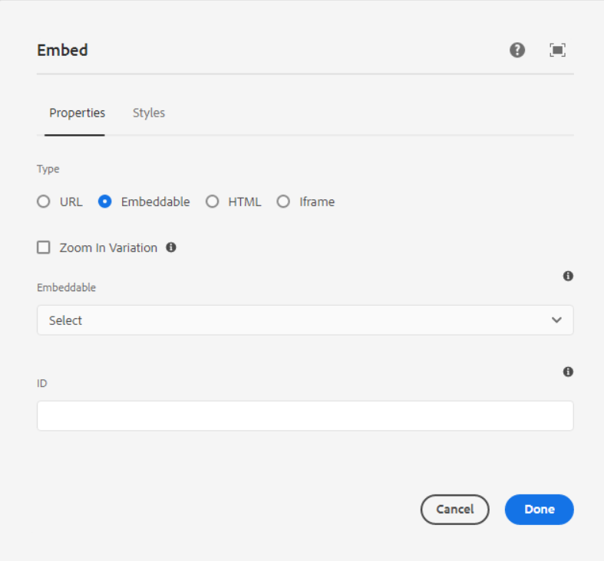

**Checkbox for Zoom in Variation** – If we want to show video on large format then we need to select this checkbox.

**Embeddable** - Select an embeddable to include on the page. Options for the embeddable are shown once selected.

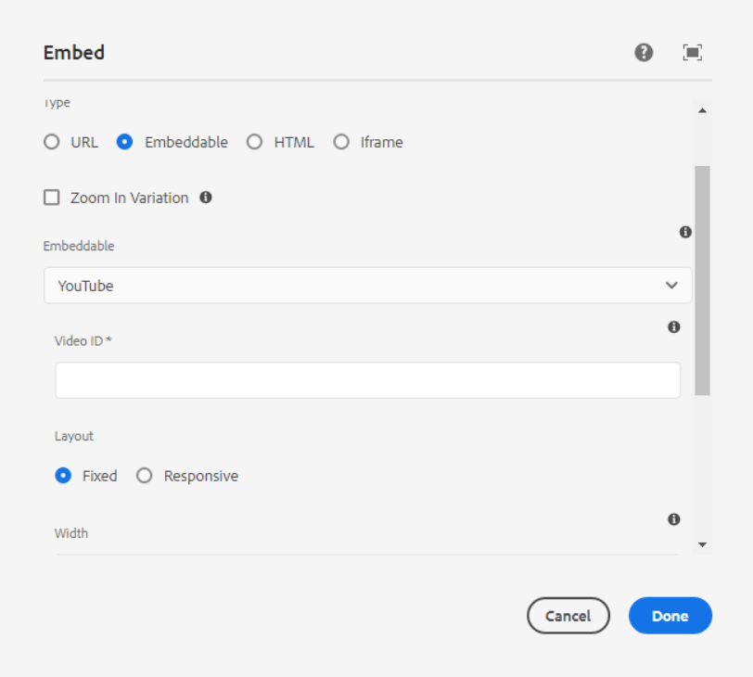

If we select embeddable as YouTube, then below fields are visible.

**Video ID** – ID of the YouTube video to Embed.

**Layout** - Select one radio button as per requirement

* Fixed
* Responsive

**Width** - Width of the YouTube video player.

**Height** - Height of the YouTube video player.

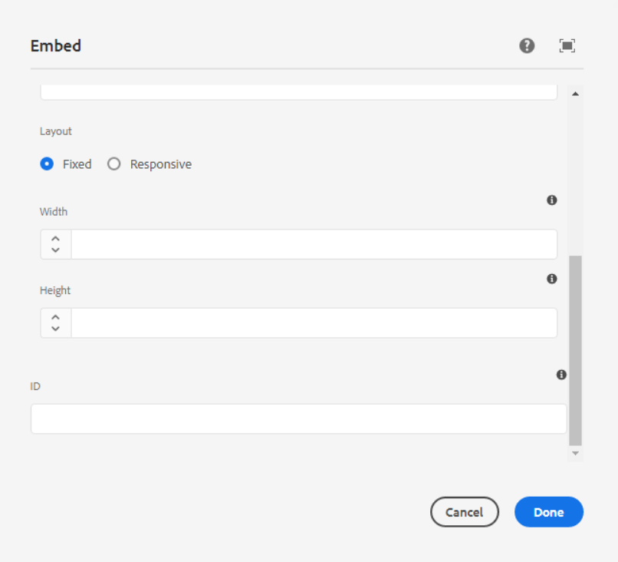

**ID** – HTML ID attribute to apply to the component.

------------------------------------------------------------------------------------------------------------

1. **HTML**

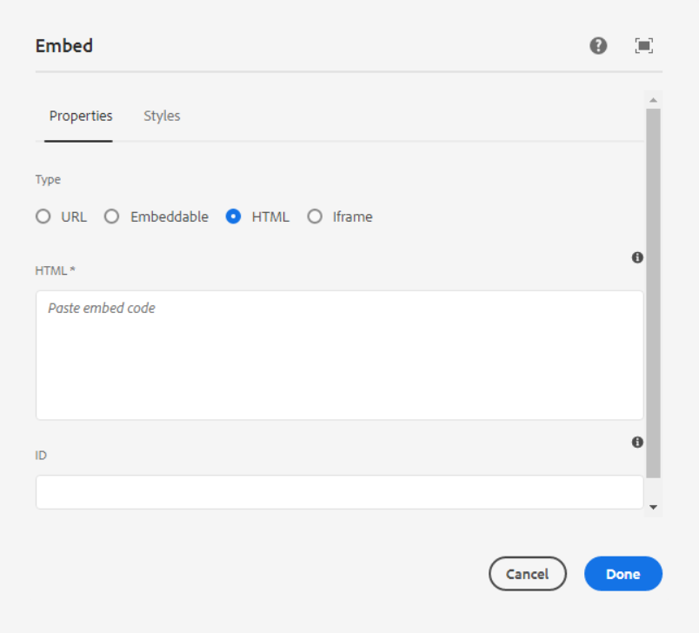

**HTML** - Here we can paste the Embed code

**ID** – HTML ID attribute to apply to the component.

------------------------------------------------------------------------------------------------------------

1. **iframe**

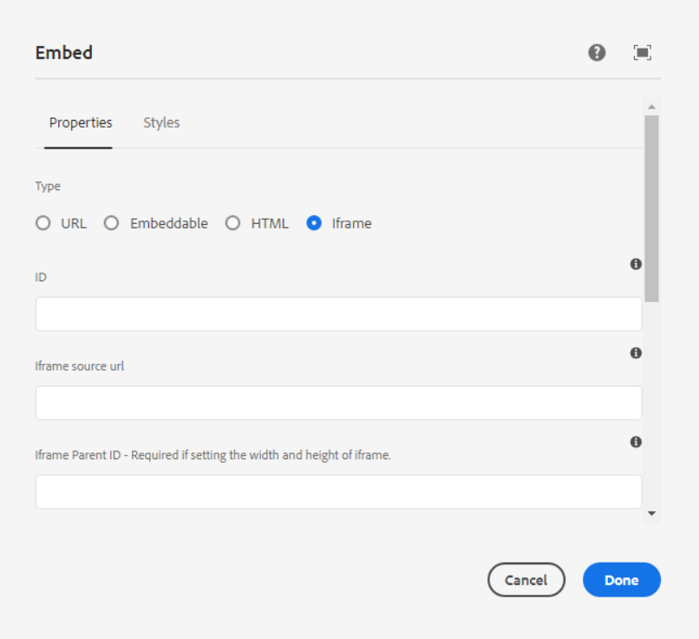

**ID** – HTML ID attribute to apply to the component.

**Iframe Source URL** - ID of the parent div of the Iframe

**Iframe Parent ID** – Required if setting the width and height of iframe

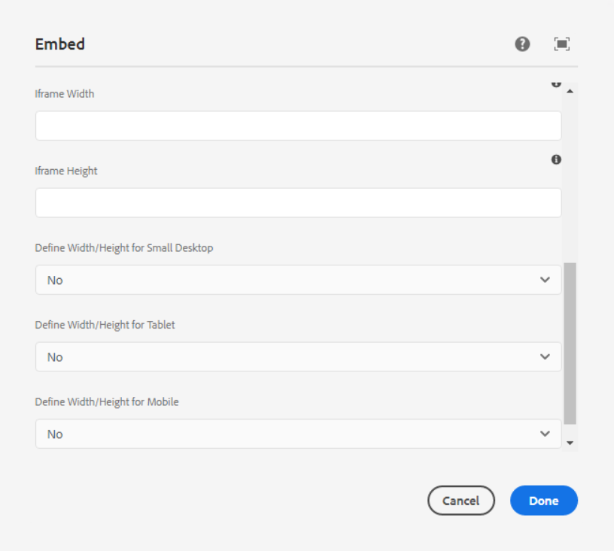

**Iframe Width** - Width of the iframe. Be sure to add the measurement value i.e. % or px

**Iframe Height** - Height of the iframe. Be sure to add the measurement value i.e. % or px

**Define width/Height for small Desktop** - In the dropdown, if we select yes then below fields are visible.

Width and height value should be in PX format, % value will not accept

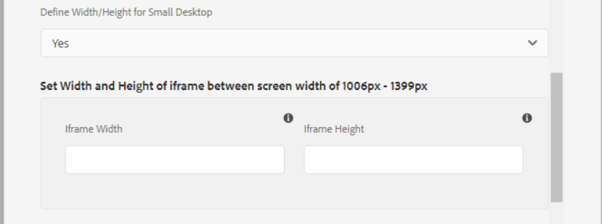

**Define width/Height for Tablet** - In the dropdown, if we select yes then below fields are visible.

Width and height value should be in PX format, % value will not accept

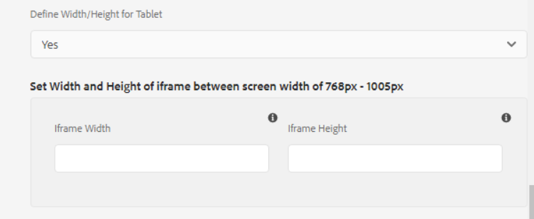

**Define width/Height for Mobile** - In the dropdown, if we select yes then below fields are visible.

Width and height value should be in PX format, % value will not accept

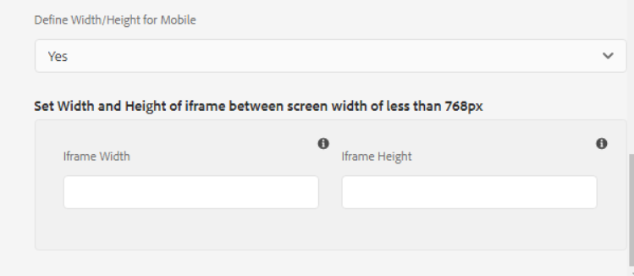

___________________________________________________________________

Style Option

Using this option, we can align iframe position on the center of the content.

